The Refined Process Structure Tree

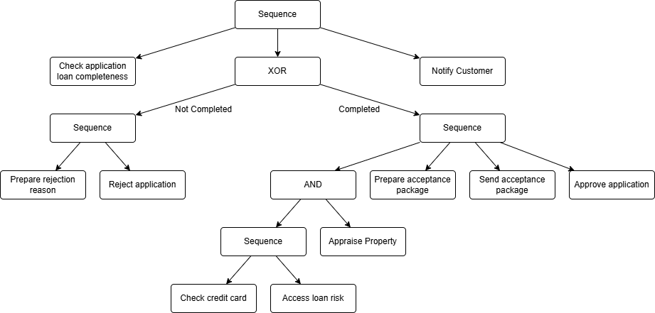

- Effective time for Case 1 in hours = 5 + (MAX[(3 + 0.5), 3] + 24 + 2 + 1.5) + 0.5 = 36.5 hours
- Effective time for Case 2 in hours = 5 + 3.5 + 0.5 = 9 hours

